Experiment-5

1.Create schema college

SQL> create schema college;

2.Create table-student and attributes are studid,

studname, gender, subject, marks, grade

3.Create table-Faculty and attributes are fac_id, fac_name , course, pass percentage

4.Create table-department and attributes are dept_no, dept_name, section, no of students, pass percentage

5.Create table-Activity and attributes are act_id, act_name, no of students opted ,category of activity

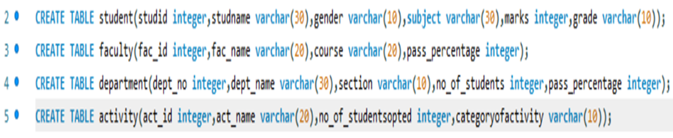

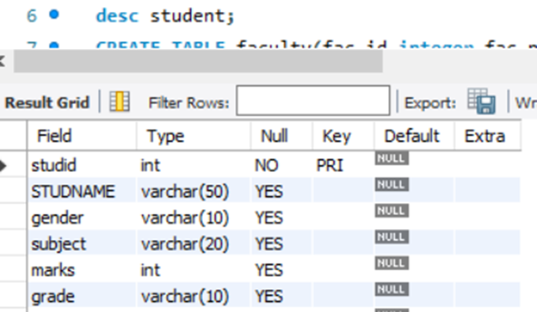

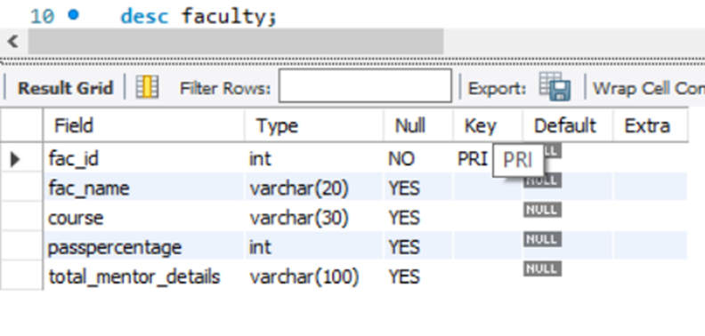

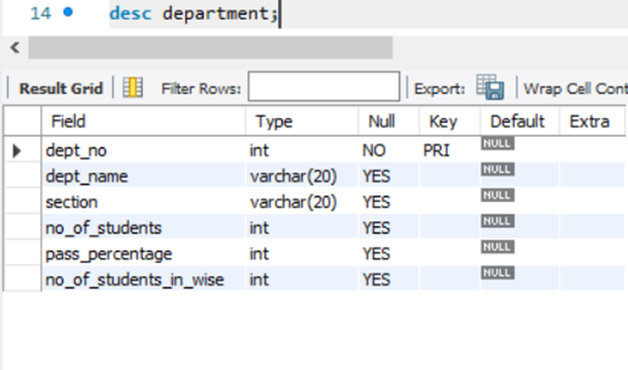

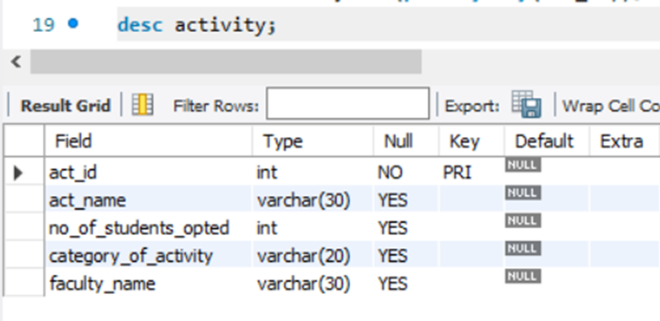

1.Add address in student table, change the datatype size for student name and make studid as primary key



2.Add faculty total mentor details ,make fac_id as primary key



3.Add no of students in wise and make dept no as primary key



4.Add faculty name and change the size of act_name and act_id as primary key

